**FORMULA 1 PROJECT – 2**

**PROJECT OVERVIEW:**

This project aims to provide a data analysis solution for Formula-1 race results using Azure Databricks. This is an ETL pipeline to ingest Formula 1 motor racing data, transform and load it into our data warehouse for reporting and analysis purposes. The data is sourced from ergast.com, a website dedicated to Formula 1 statistics, and is stored in Azure Data Lake Gen2 storage. Data transformation and analysis were performed using Azure Databricks.

**PROCESS FLOW:**

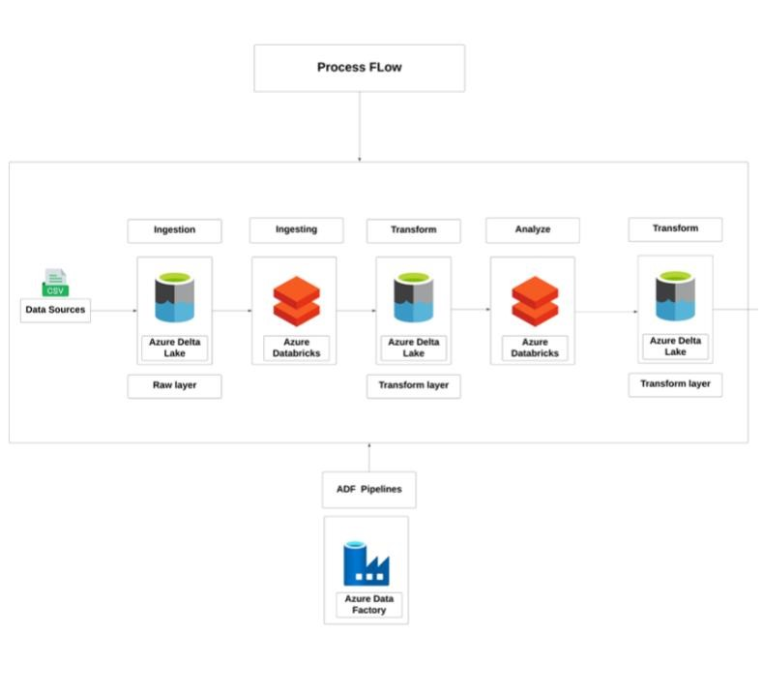

**HOW IT WORKS?**

**Source Data:**

There are various files used in this project.

**File Name** **Type**

Drivers JSON

Constructors JSON

Races CSV

Results JSON

Circuits CSV

Pits_stops JSON

Lap_times CSV

**EXECUTION OVERVIEW:**

* Firstly, we have used data factory to facilitate the copy activity. We have ingested the data into azure data lake gen2.
* Next, we have created the databricks workspace and have loaded the data into notebook from data lake.
* We have loaded all the data into different data frames and created temporary views to work on them
* Finally, we used spark SQL to write queries that are used to analyze the data.

**AZURE RESOURCES USED:**

* Azure Storage account
* Azure databricks
* Azure data lake
* Azure data Factory

**PROJECT REQUIREMENTS:**

1. **Data ingestion requirement:**

* We have all the data files in an azure blob storage
* Next, we have used data factory to create a pipeline to ingest all the data into azure data lake gen2
* So, a copy activity has been performed
* With this the data ingestion requirement is satisfied

1. **Connection Requirement:**

* Create a new databricks workspace
* Find the data lake name and key from access keys
* Create a cluster and a new notebook in the databricks
* Initialize variables with name and key of the data lake
* Use conf.set to make a connection between the databricks and azure data lake
* With this both services are connected

1. **Data cleaning and transformation**

* Once the data is loaded, we perform cleaning and transformation techniques
* In this requirement, we have dropped all the missing values and done some changes in columns
* Later we have created views to analyze the data in next step.

1. **Data Analysis Requirement**

* After the data transformation, we have created views
* We have used Spark SQL is write queries
* Using these queries, we can analyze the data and draw the insights hidden in the data.

**TASKS PERFORMED:**

There are various tasks performed in this project:

* Build a data engineering solution for analysis of formula 1 race data
* Used Azure data factory for the copy activity of the data into the Azure data lake gen 2.
* Used Azure databricks to write the code for analysis
* Established a connection between Azure storage account and Azure databricks through access keys
* Mounted the data into the azure databricks storage
* Performed the data cleaning and transformation operations
* Created views in databricks
* Used Spark SQL to write queries
* Written spark SQL code to identify the trends in the data.
* Written spark SQL code to analyze the data.

**OUTPUT/ RESULTS:**

Firstly, we have a blob storage and in that I have a container where all the data files are present.

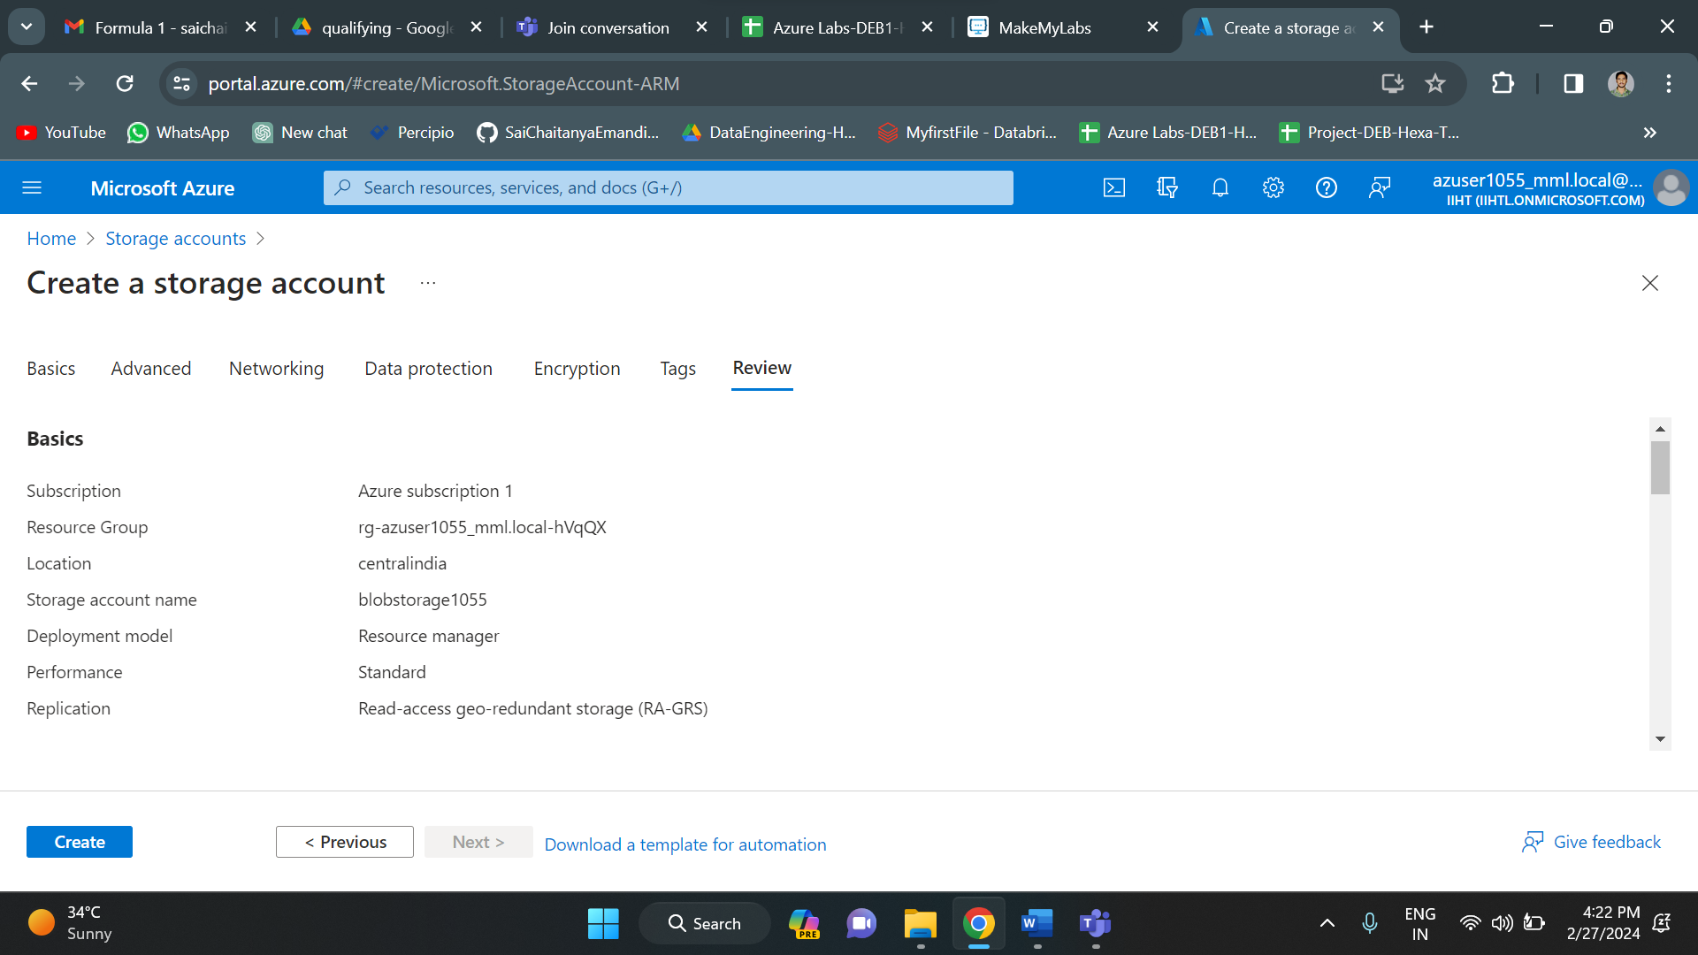

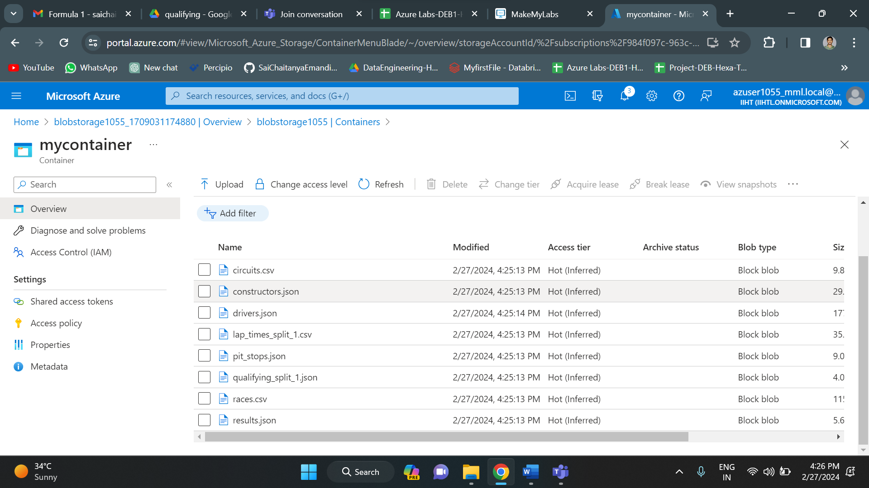

Creating an azure data lake gen 2 storage by enabling the hierarchical namespace.

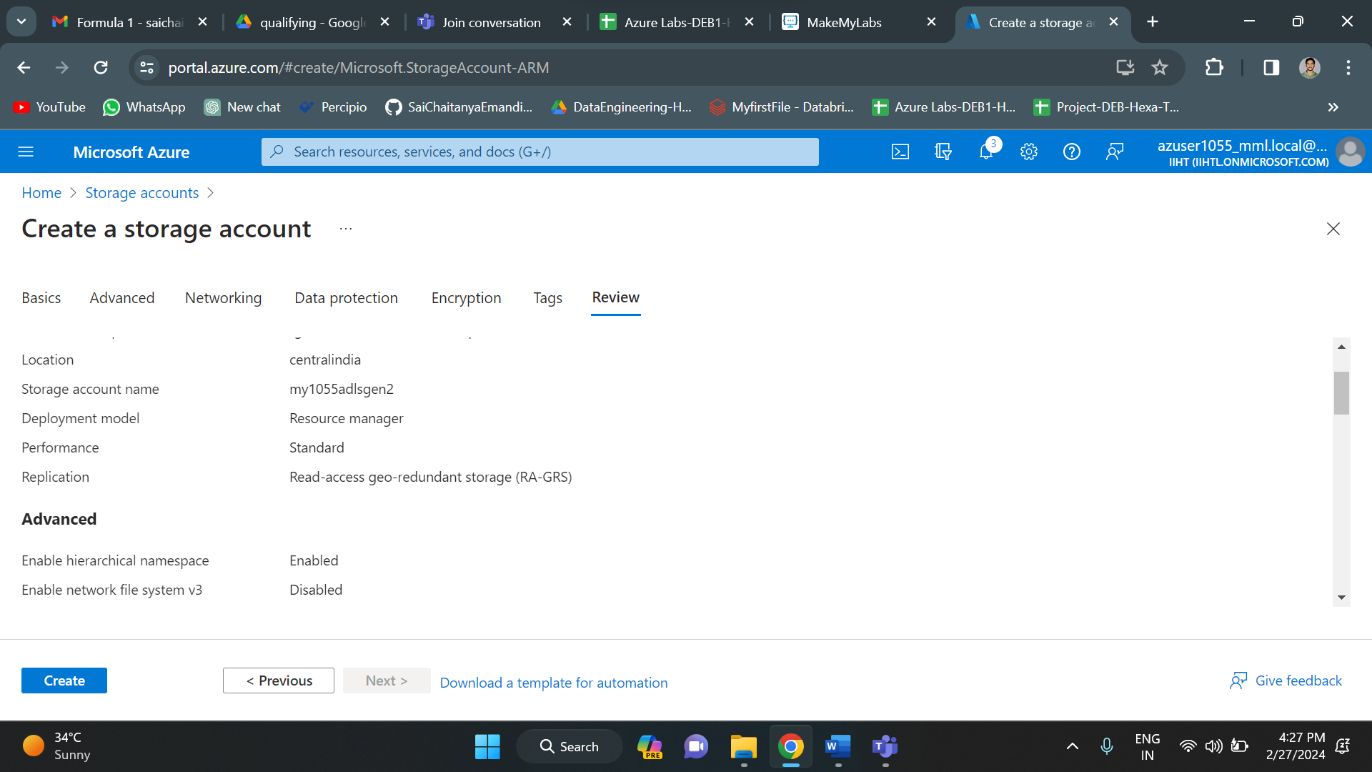

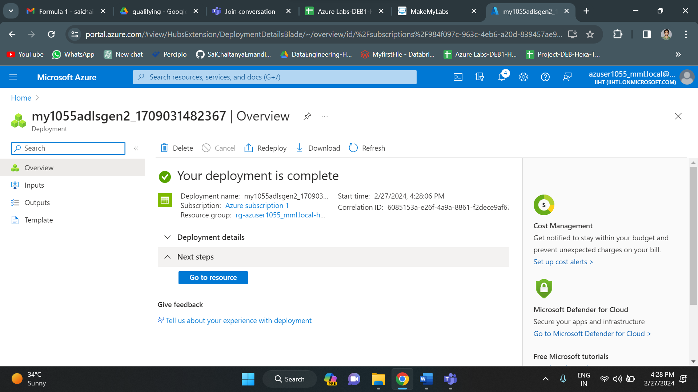

Created a container called “adlscontainer” in the data lake gen 2 storage.

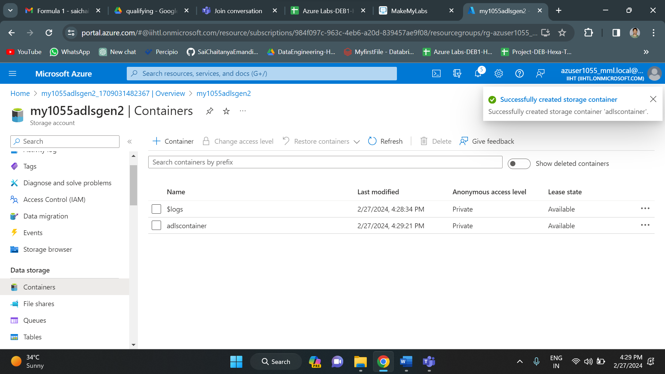

Created data factory to create a pipeline for copy activity.

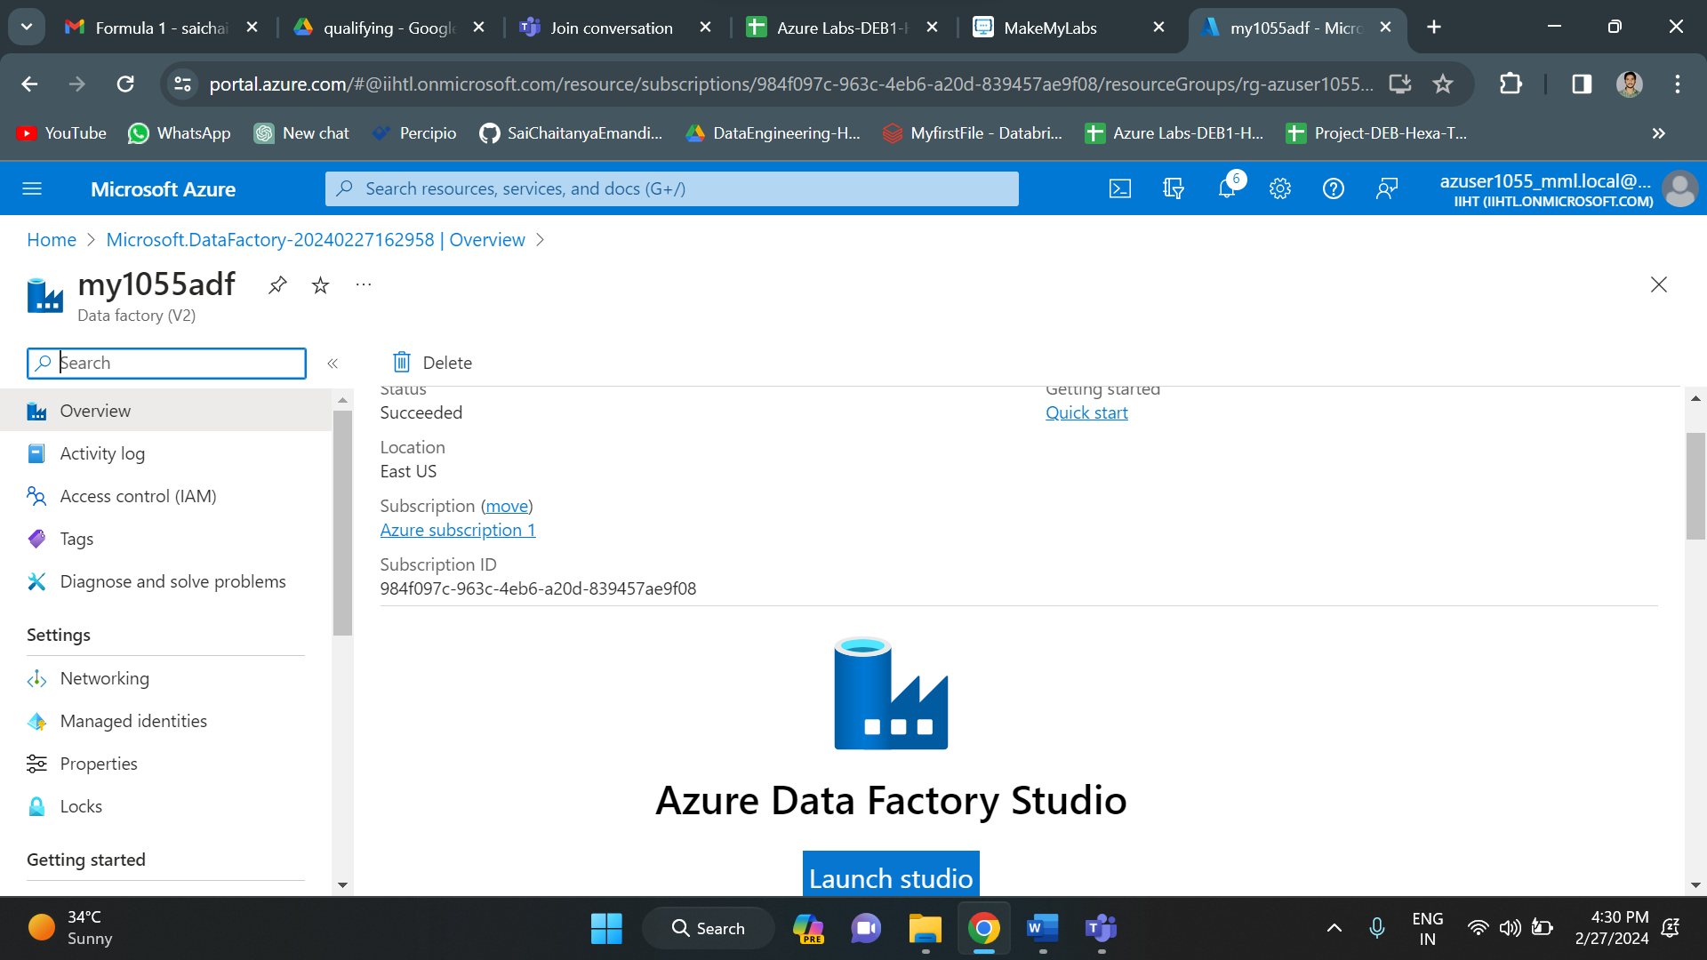

Ingesting the data.

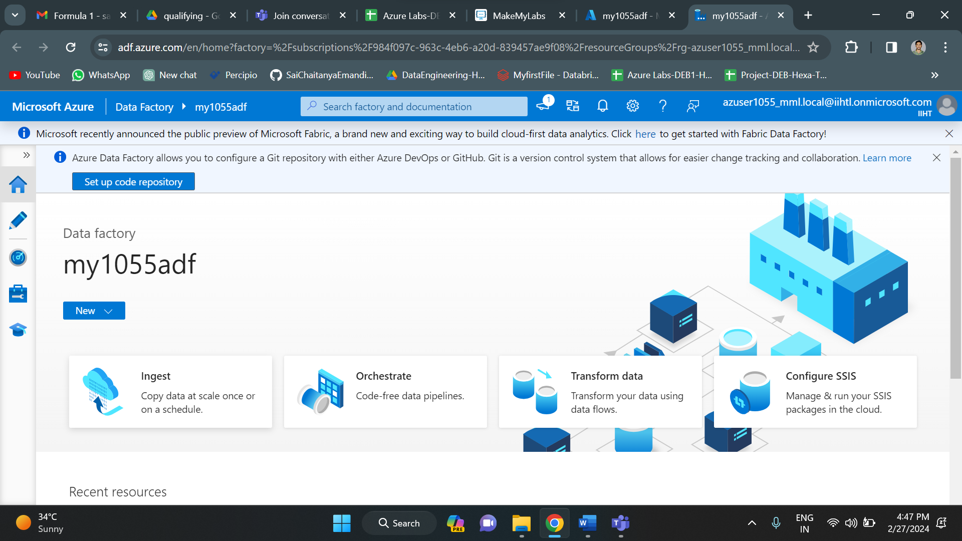

Setting all the source and destination connections.

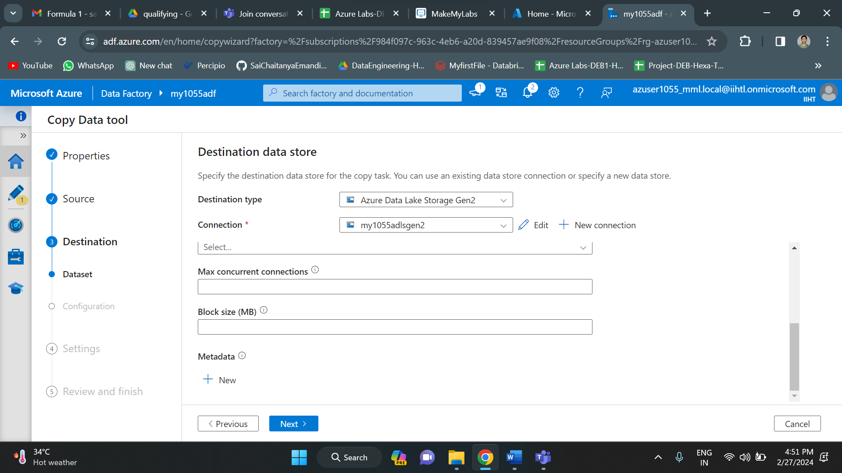

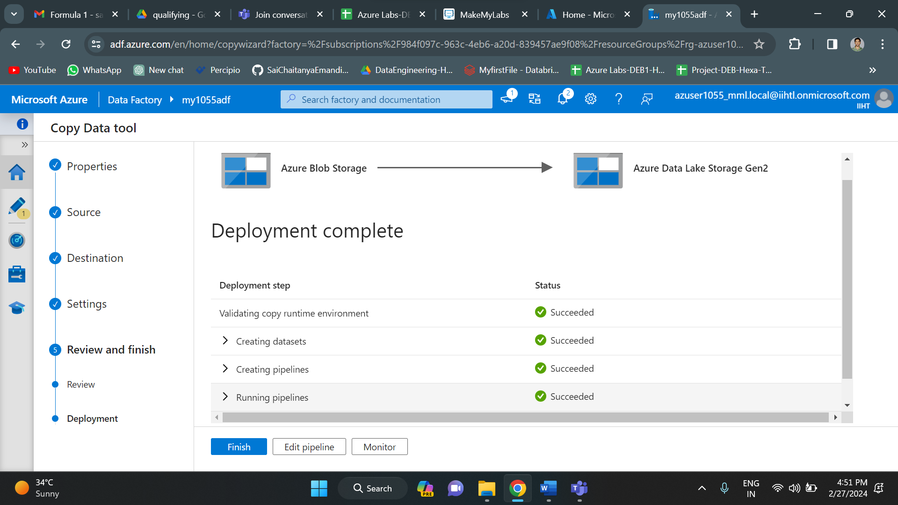

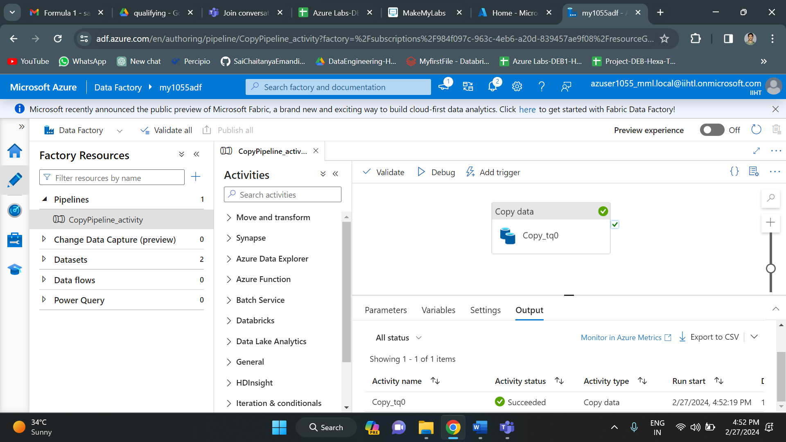

Finally copy activity has been successful. As you can see, we have successfully validated and debugged. Below you can see all the data files in data lake gen 2.

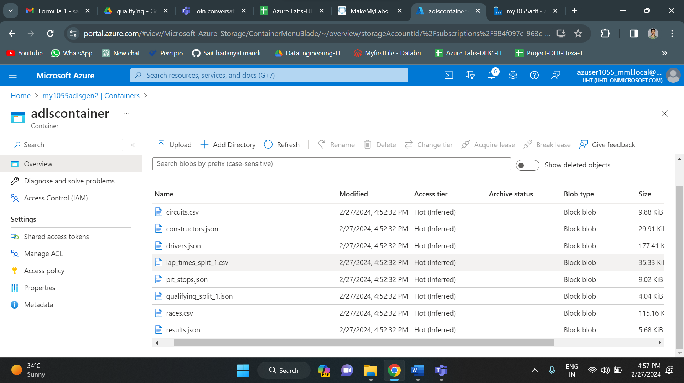

Now for analysis part, we need to create a databricks workspace.

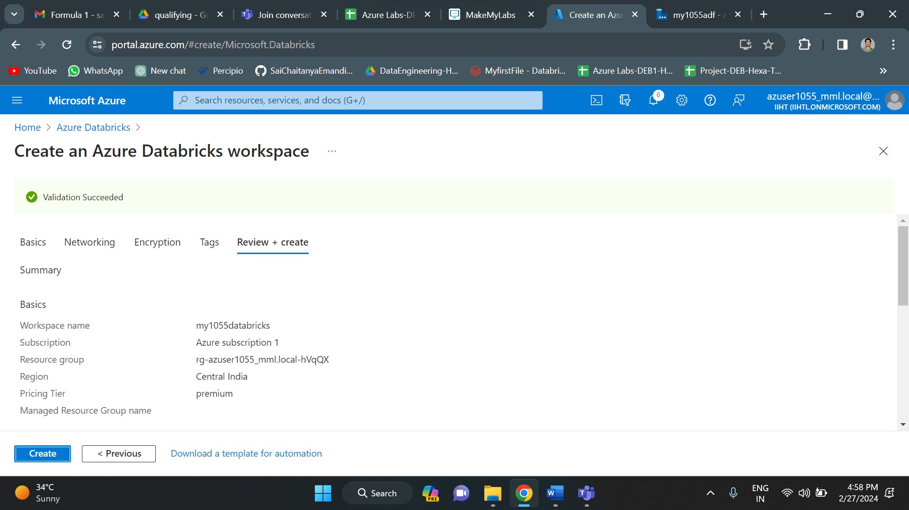

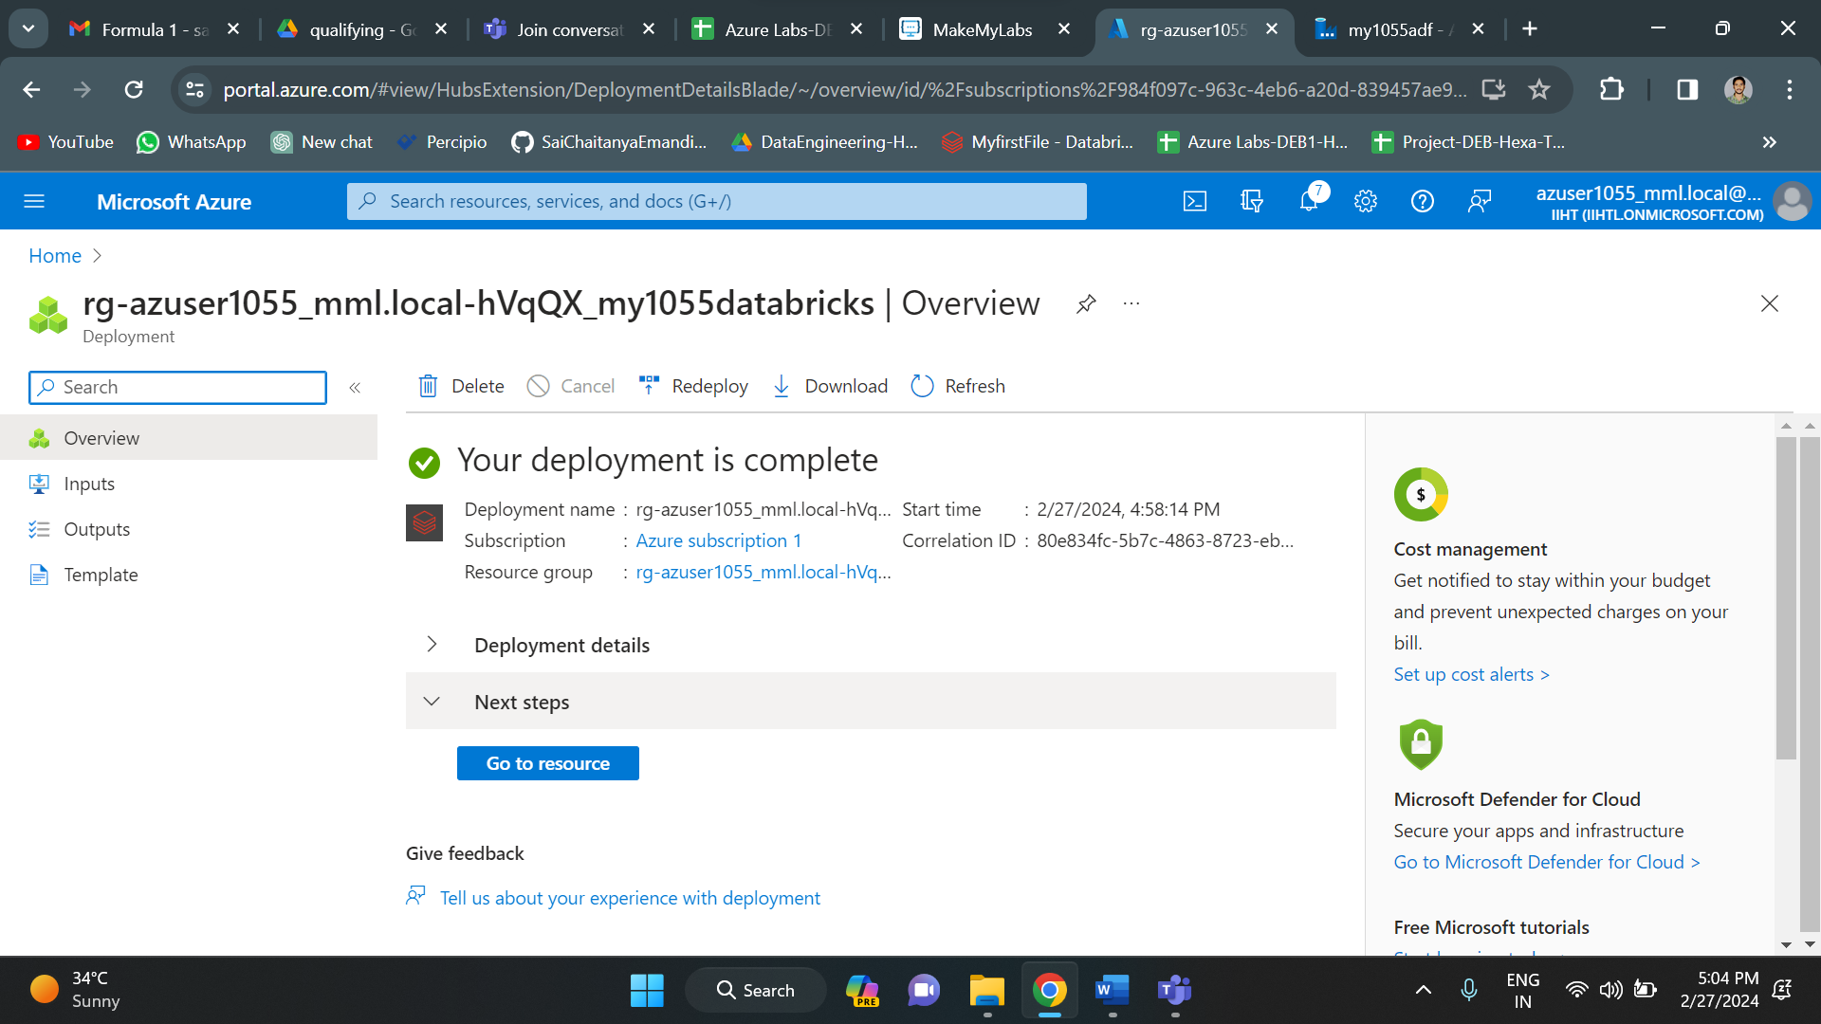

Creating a cluster in databricks workspace

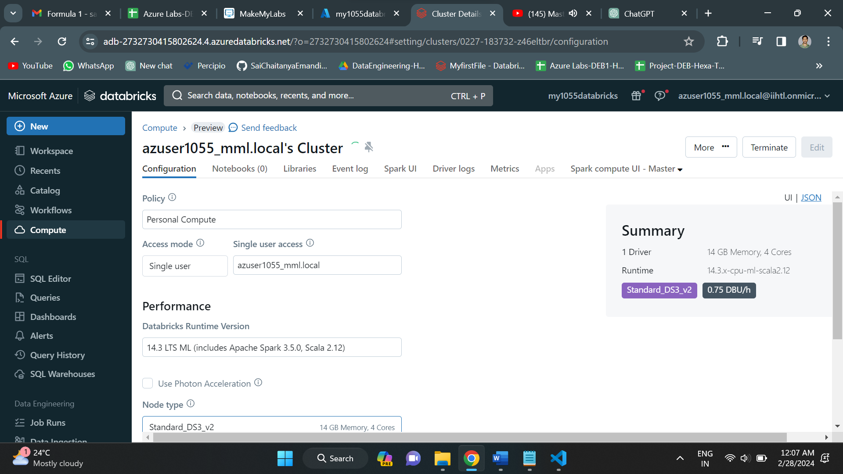

Once the cluster got created, click on new to create a new notebook.

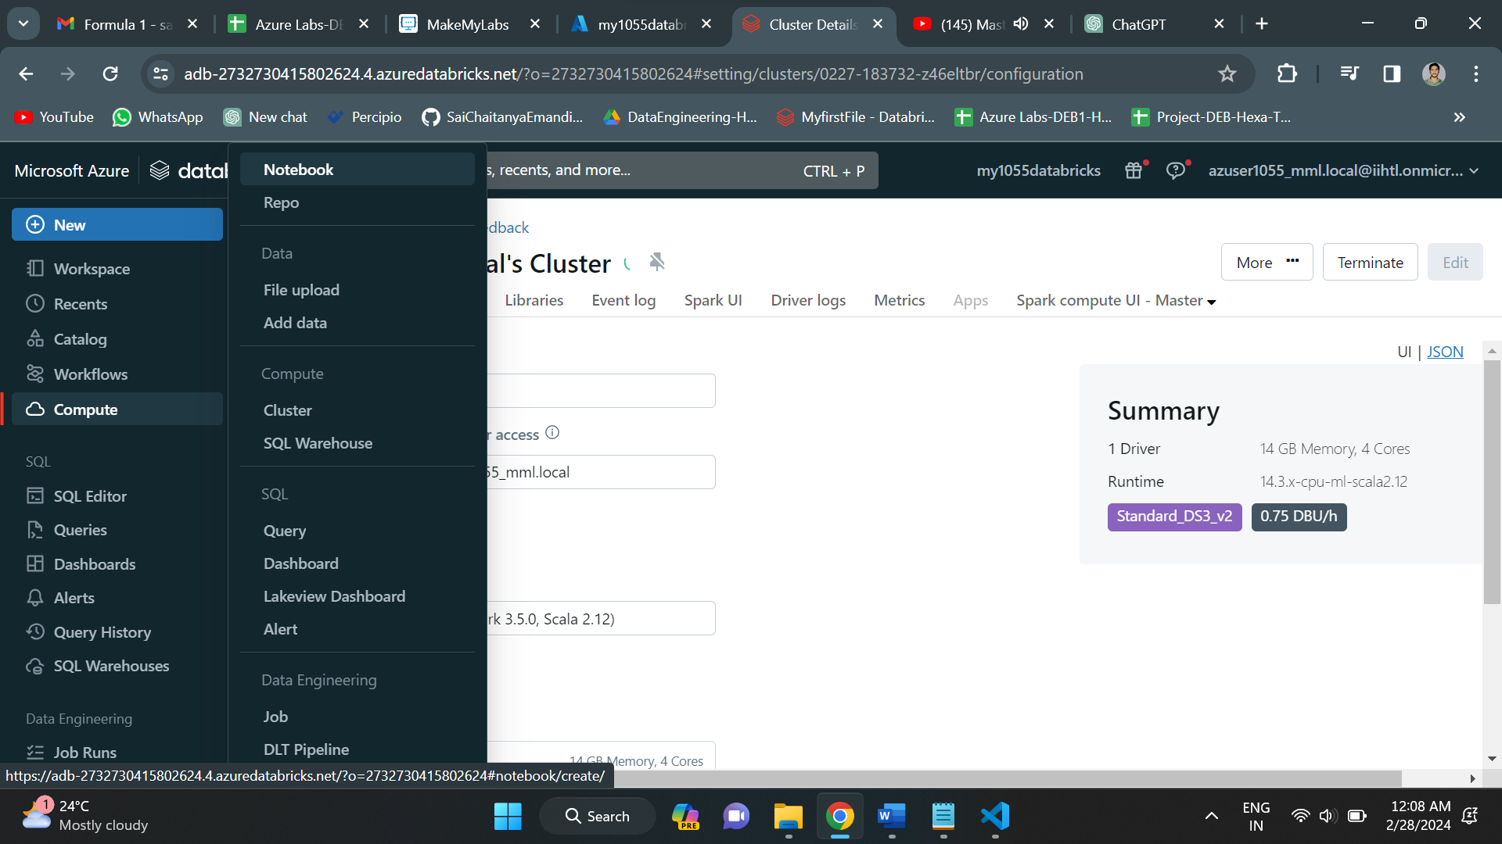

Now, we can write code for analysis of the data.

Creating a spark session.

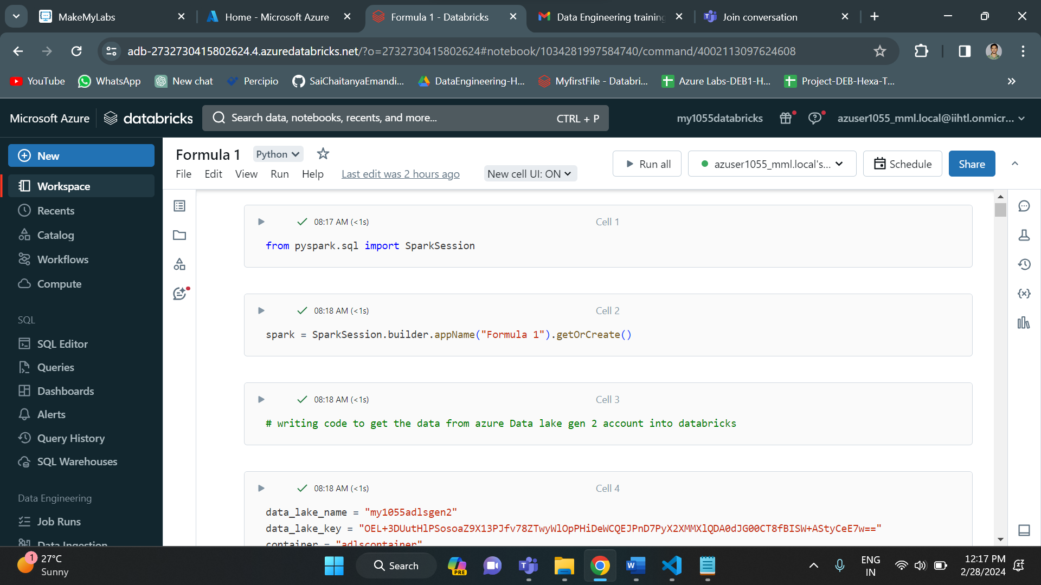

Writing code to connect the data lake and databricks

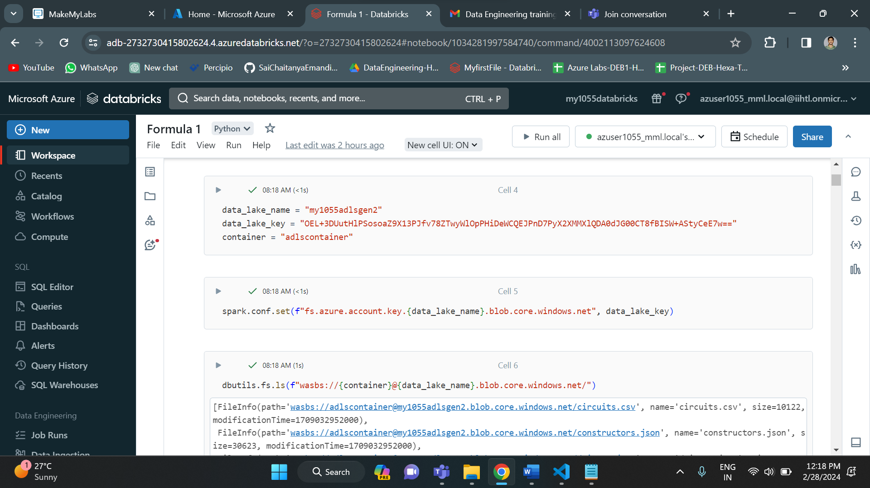

Loading the data into dataframe

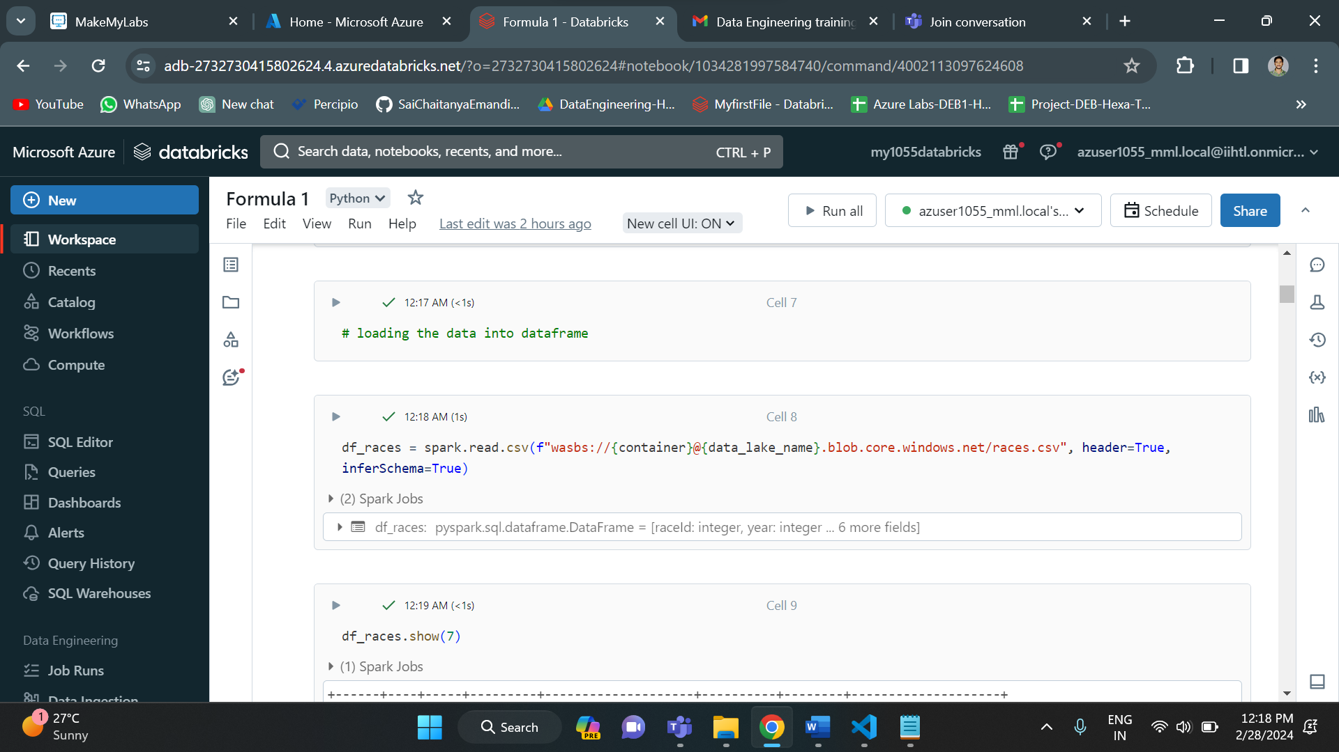

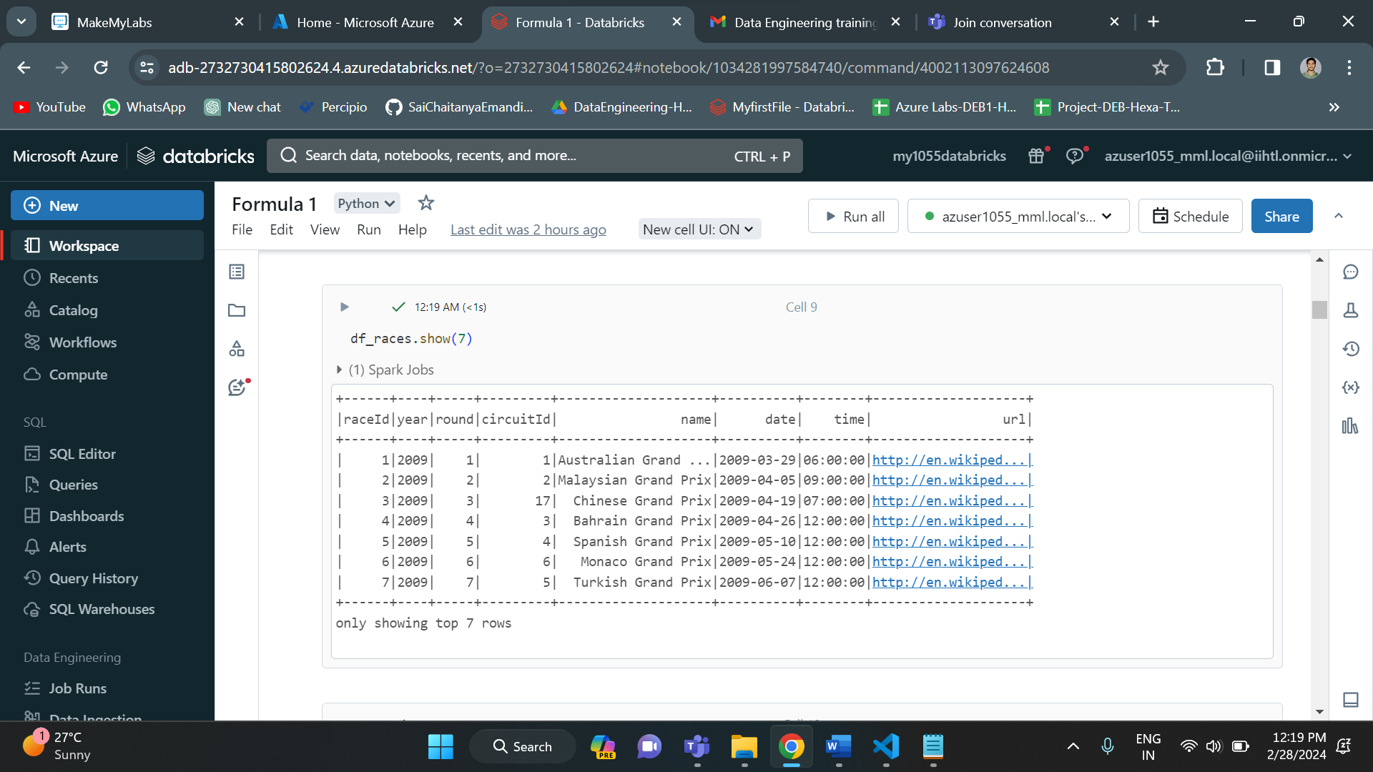

Mounting the data

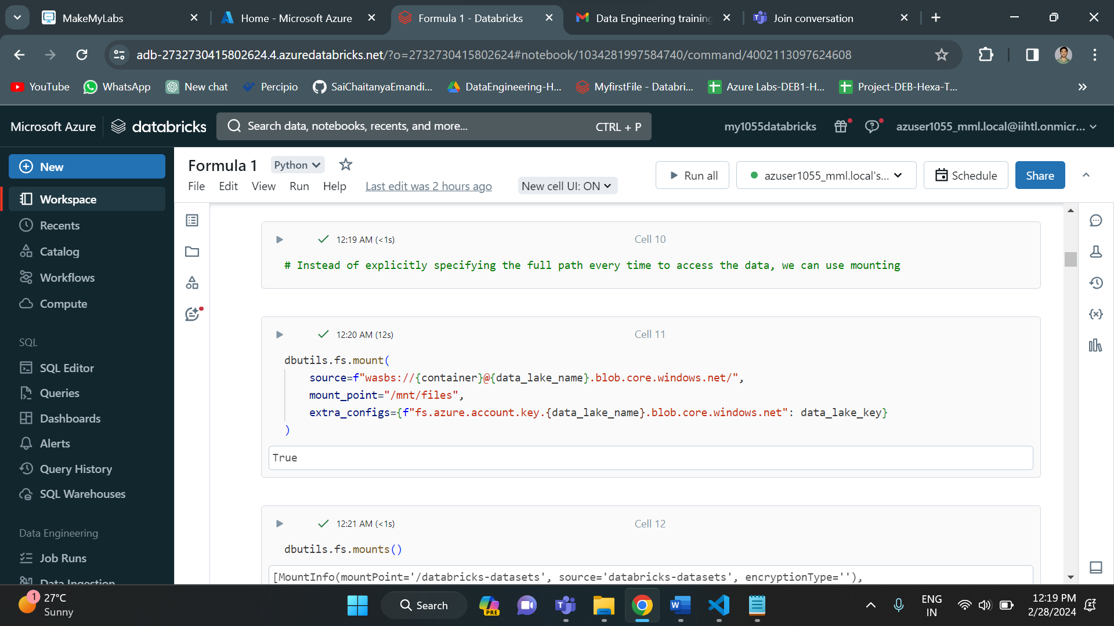

Working on races.csv file

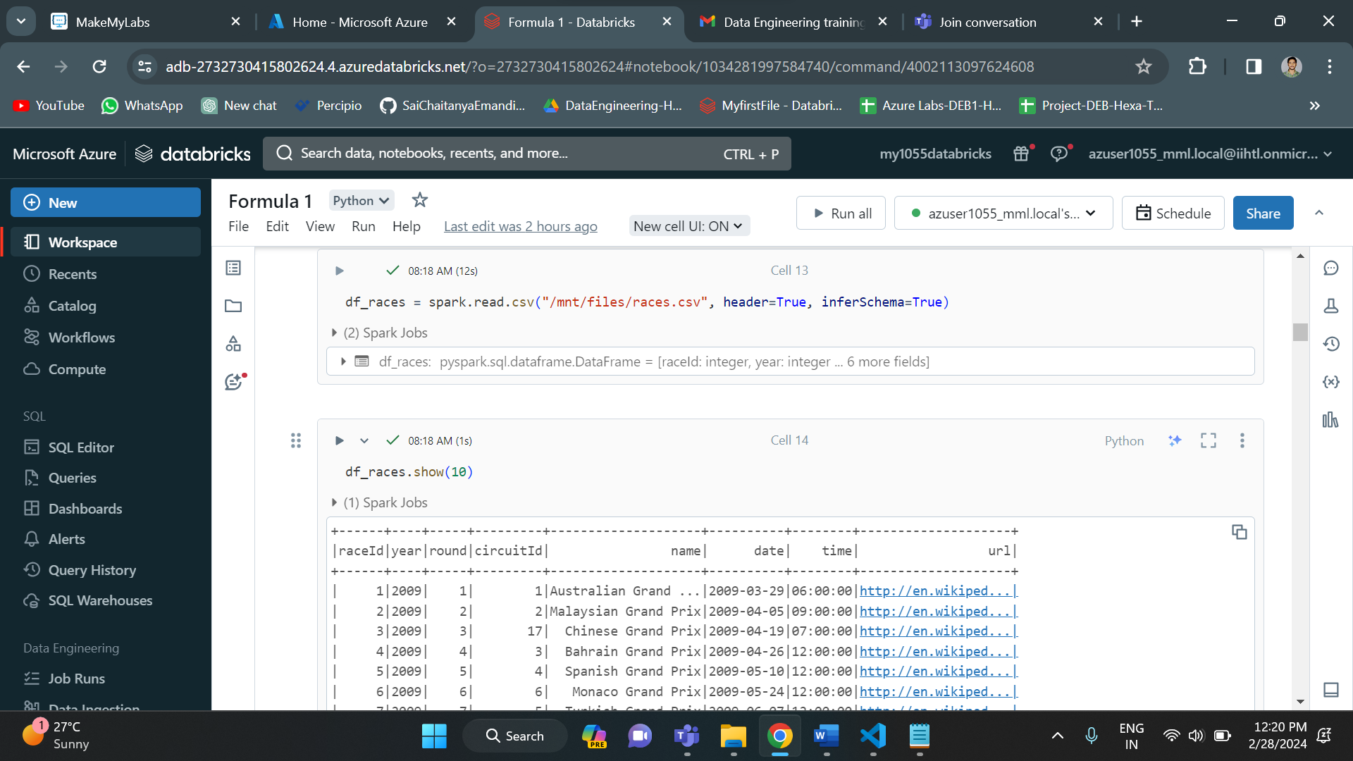

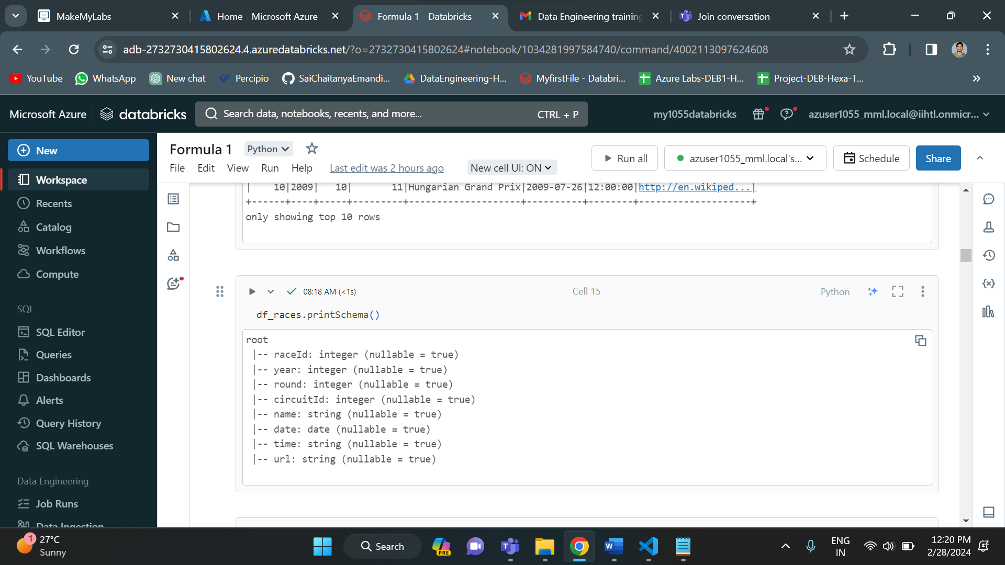

Loaded the circuits.csv file into dataframes.

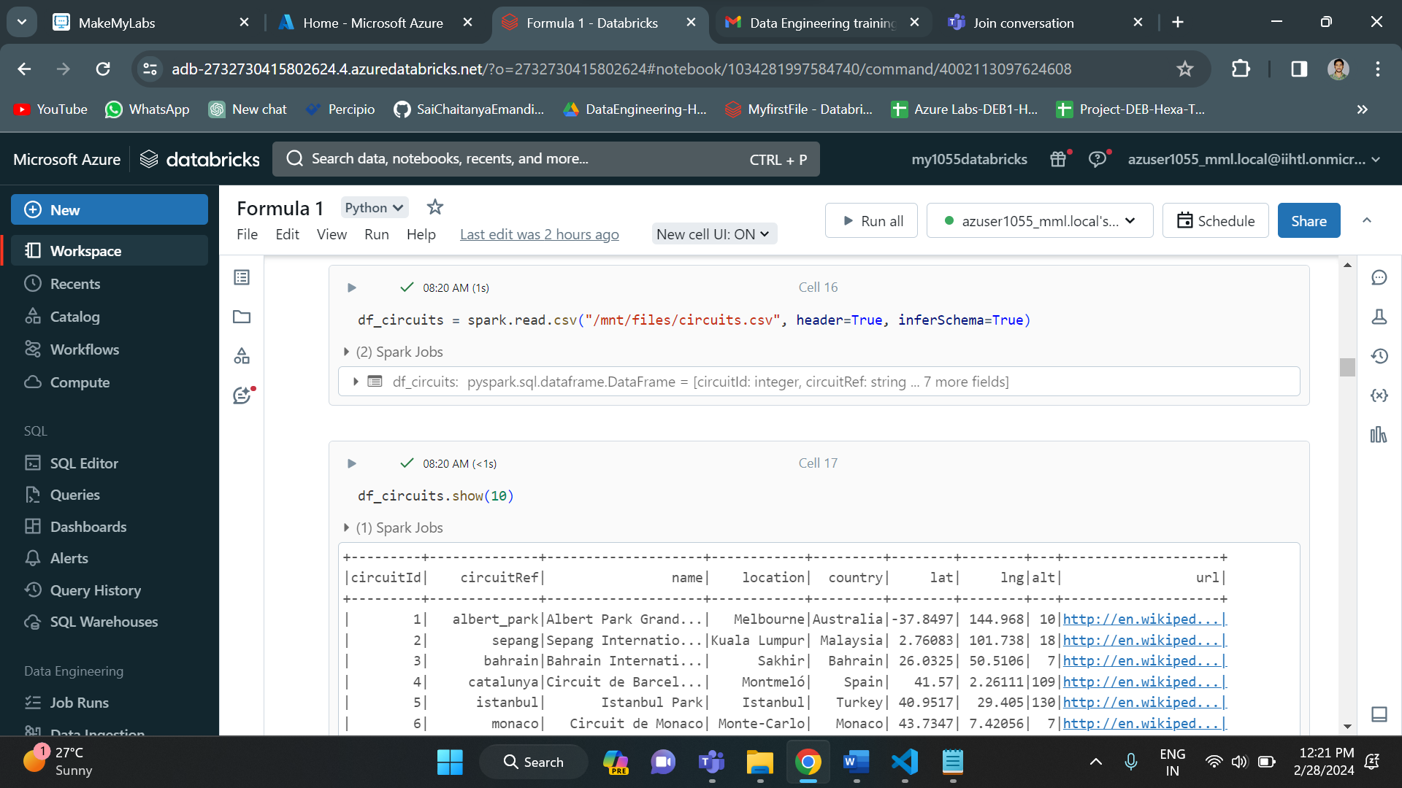

Similarly, we have loaded all the data files into the azure databricks data frames.

Merging of dataframes

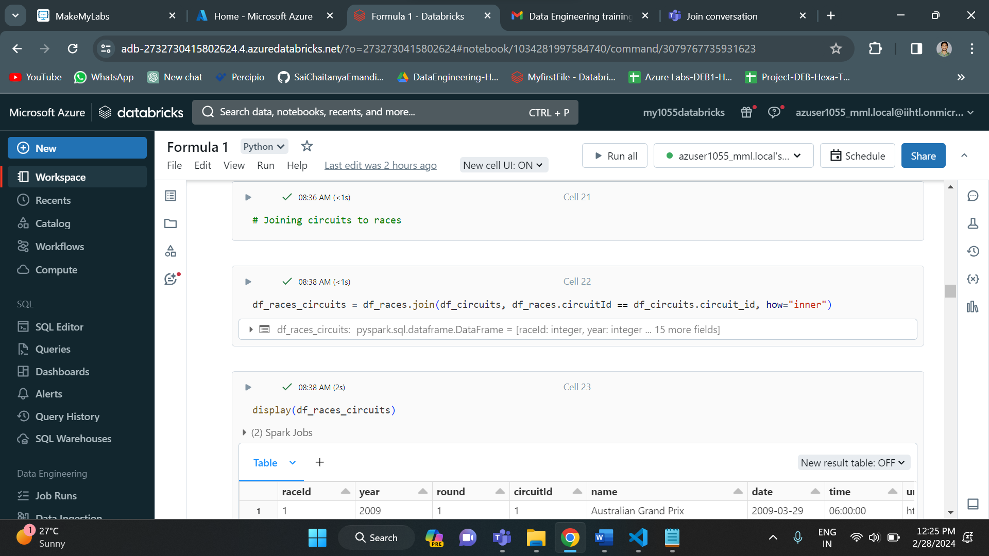

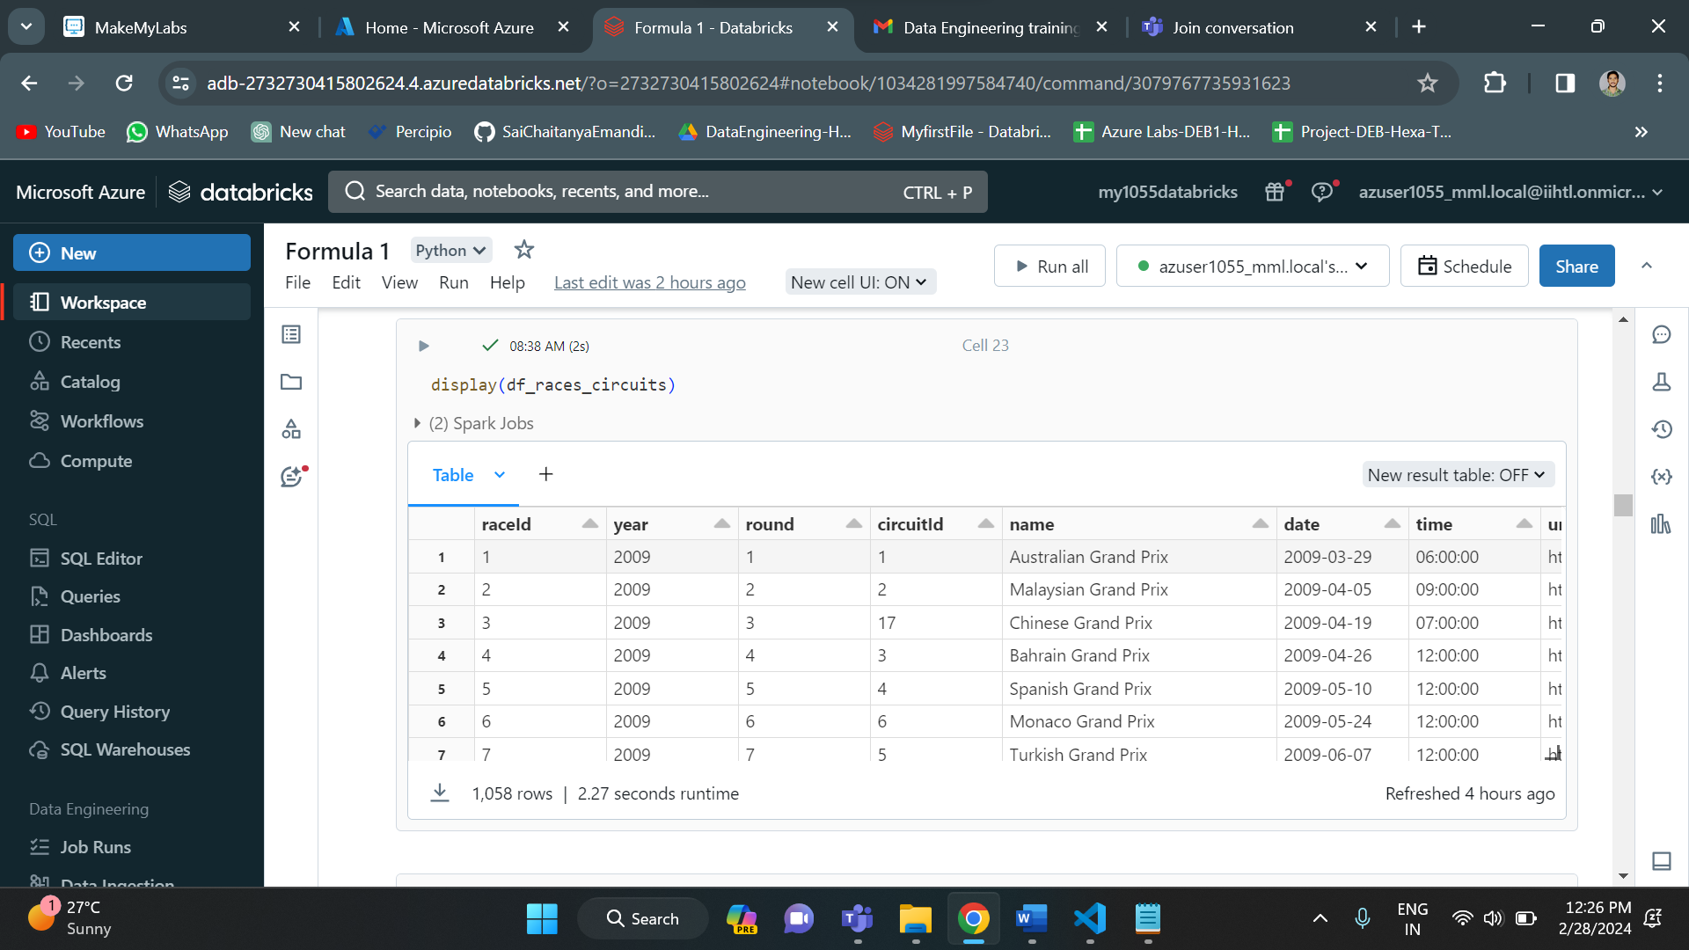

Below is the visualization of data

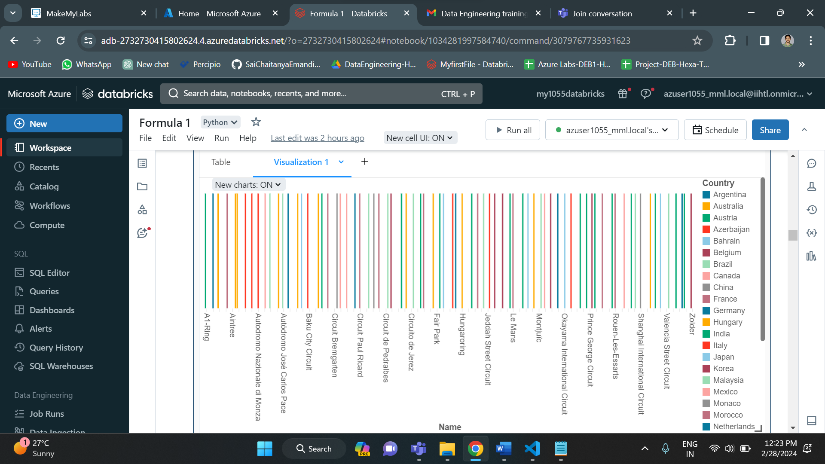

Now we have created views to write spark SQL codes for analysis.

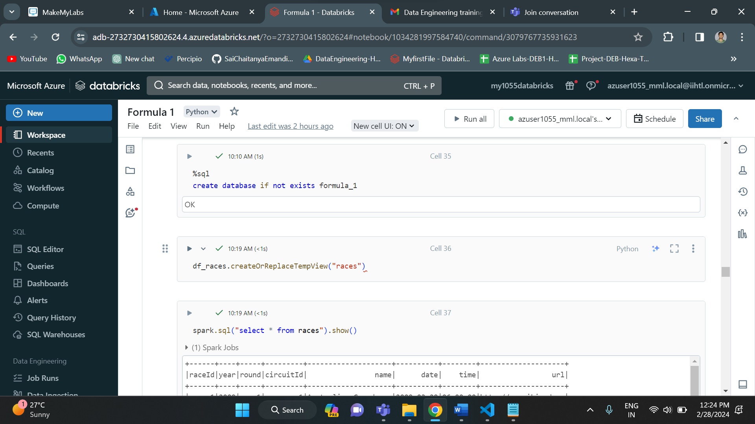

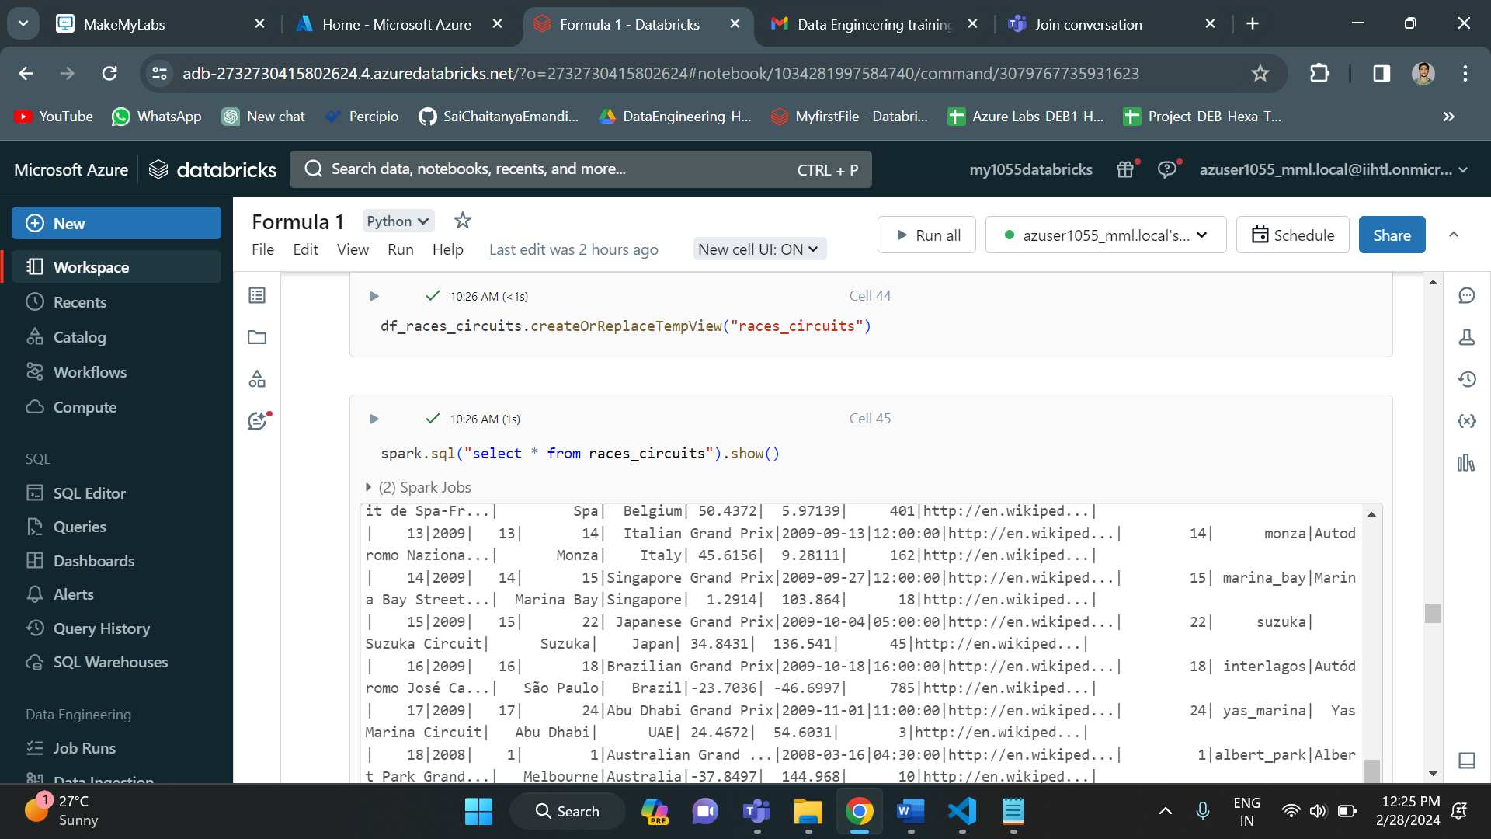

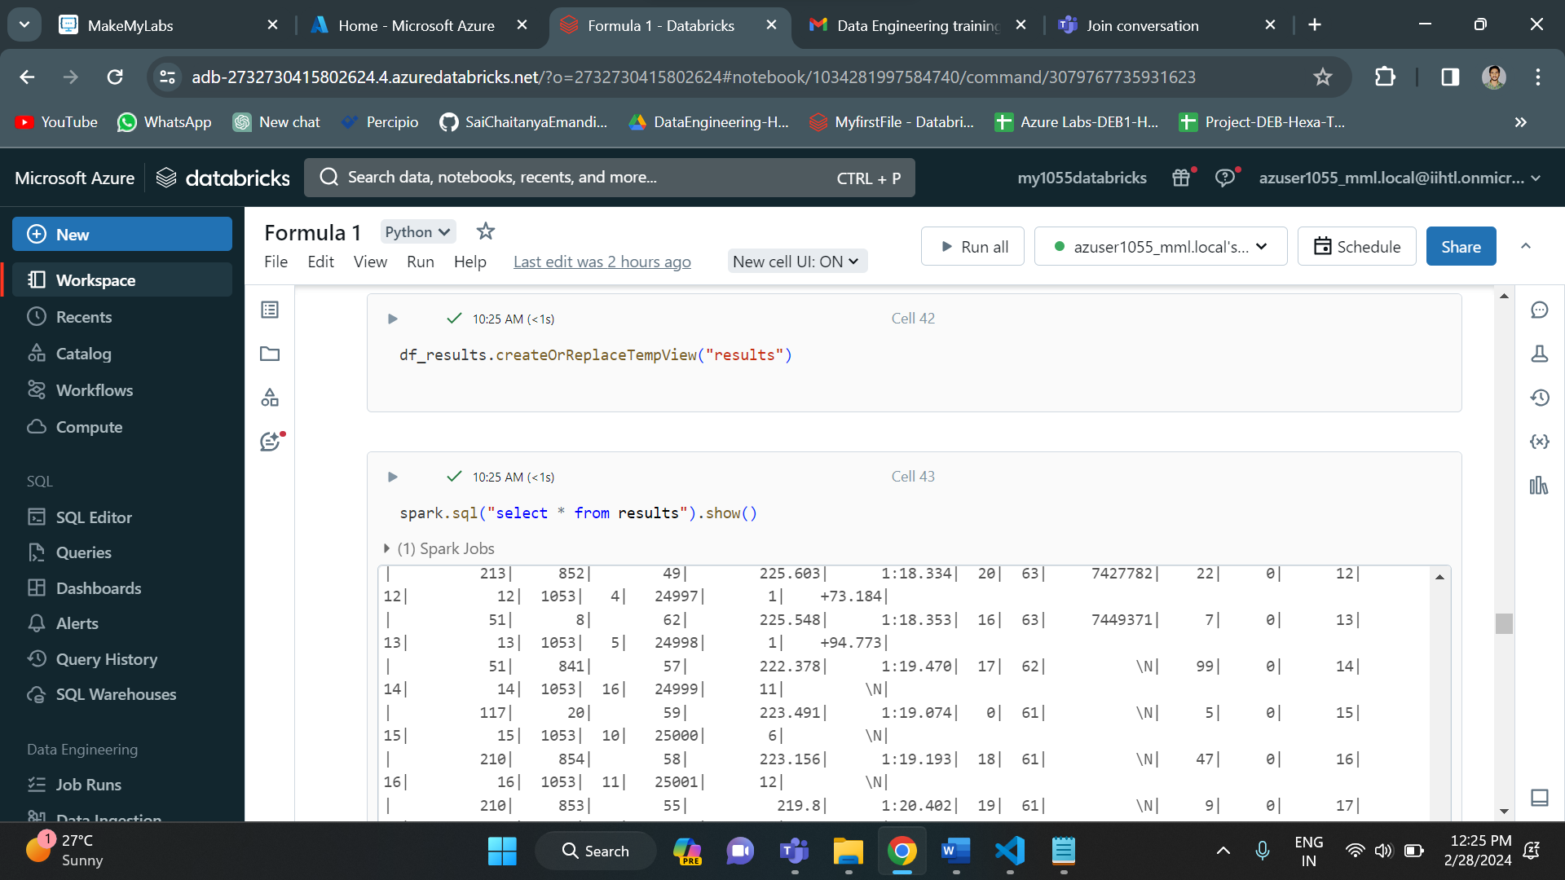

**Analysis of the data:**

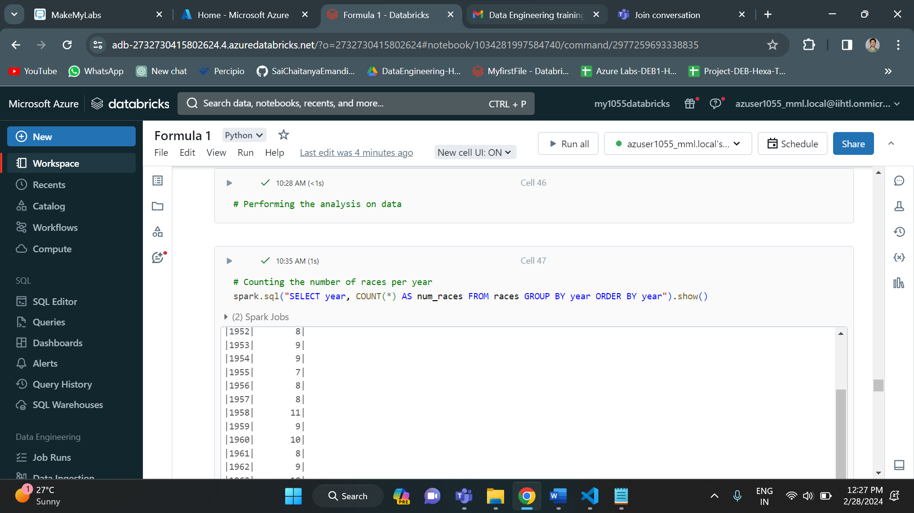

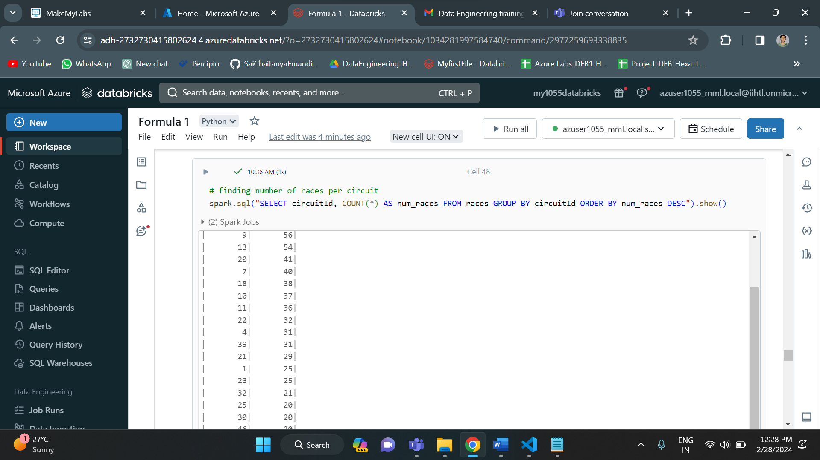

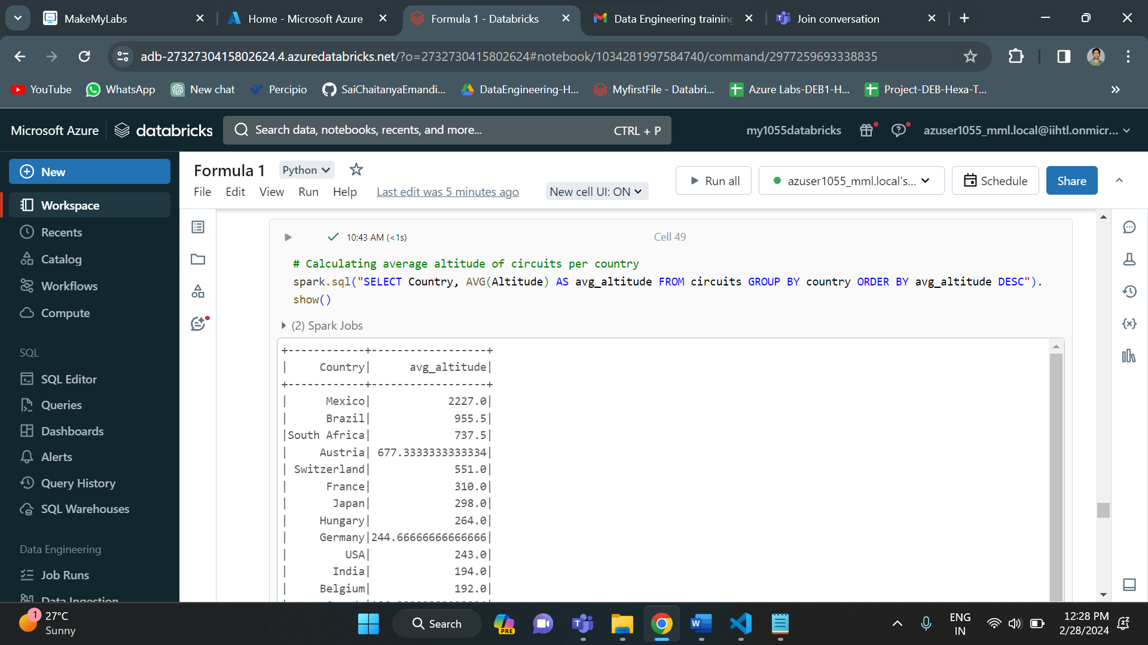

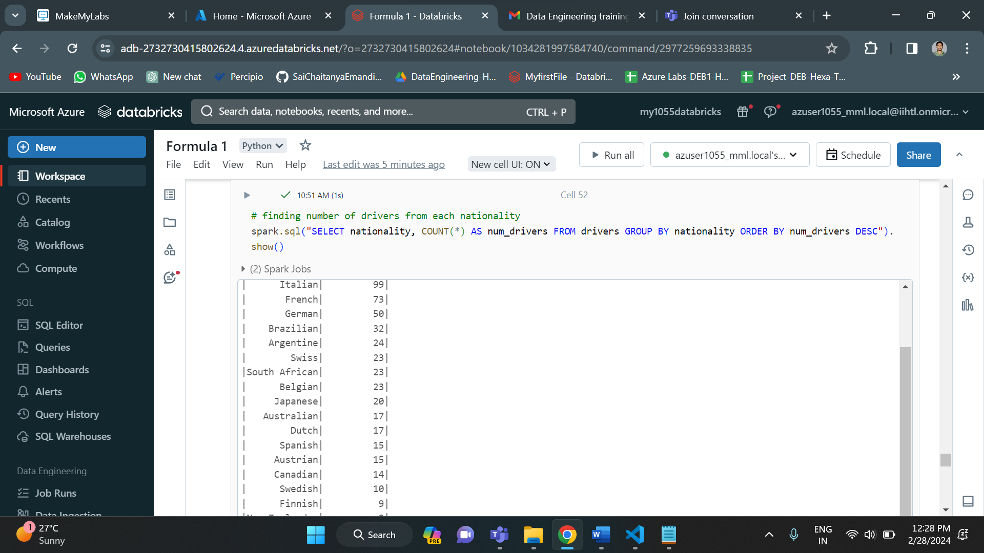

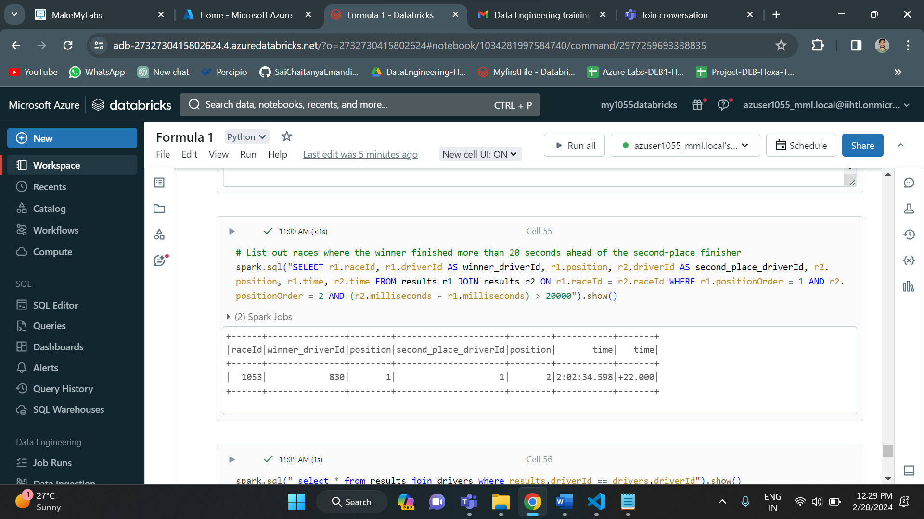

**CONCLUSION:**

Our Formula 1 data analysis project leverages Azure Databricks, Azure Data Lake Gen2 storage, and Azure Data Factory to construct a robust ETL pipeline. By sourcing data from ergast.com and employing Azure services, we streamline data ingestion, transformation, and loading processes. Azure Databricks facilitates efficient data manipulation and analysis, empowering insightful reporting for Formula 1 race results. Through seamless orchestration via Azure Data Factory, our solution ensures scalability and reliability in handling Formula 1 data. This integrated approach not only enhances performance but also provides a foundation for comprehensive analysis, driving deeper insights into the dynamic world of Formula 1 racing.